High or loud?

To describe a sound you need to use the just right word.

To do
Fill in the gaps to describe the sounds that are made.
You should only use the words high and loud.
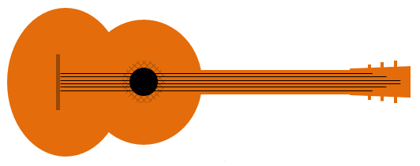
To answer
Playing a guitar
Plucking a guitar makes the strings vibrate.
Thin strings vibrate very quickly and make __________ notes.
Plucking hard on a string makes it vibrate a lot and its note is __________.
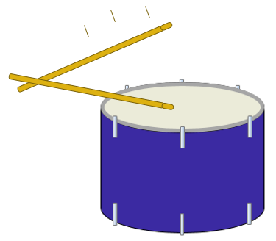

Beating a drum
When a drum is hit hard its sound is __________.
A tight drum vibrates very quickly and has a __________ sound.
When a drum has large vibrations it is __________.

Physics > Big idea PSL: Sound, light and waves > Topic PSL1: Sound and light > Key concept PSL1.1: Production and transmission of sound
Diagnostic question
High or loud?

Overview
Learning focus: | Objects and materials can be made to vibrate to produce a sound that becomes louder as the size of vibration increases and higher pitched as the rate of vibration increases.
Observable learning outcome: | Describe the effect of larger vibrations on a sound.  Describe the effect of faster or slower vibrations on a sound.
Question type: | Focused cloze
Key words: | Vibrate, vibration, high, loud

What does the research say?
There has been relatively little research that has focused on students’ understanding of pitch and loudness. Students however, often confuse the terms high and loud (or low and soft) when describing sounds.
This question examines whether students can use the terms high and loud correctly to show they understand the sounds made by different types of vibration.
Ways to use this question
Students should complete the activity individually as a pencil and paper exercise. The large print on the worksheet means that it is clear on an A5 copy, which fits neatly into a standard exercise book.
How students fill in the gaps will show you whether they understood the concept sufficiently well to apply it correctly.
If there is a range of answers, you may choose to respond through structured class discussion. Ask one student to explain why they gave the answer they did; ask another student to explain why they agree with them; ask another to explain why they disagree, and so on. This sort of discussion gives students the opportunity to explore their thinking and for you to really understand their learning needs.
Differentiation
You may choose to read the sentences to the class, so that everyone can focus on the science. In some situations it may be more appropriate for a teaching assistant to read for one or two students.
Expected answers
Playing a guitar
Plucking a guitar makes the strings vibrate. Thin strings vibrate very quickly and make high notes. Plucking hard on a string makes it vibrate a lot and its note is loud.
Beating a drum
A drum has a big vibration when it is hit hard. Its sound is loud.
A tight drum vibrates very quickly and has a high sound.
When a drum has large vibrations it is loud.
How to respond - what next?
For the first and last answers, students have no reference to their everyday experience and must use their knowledge of how different types of vibrations make different sounds. If a student answers both of these correctly it is likely that they can apply this idea in new situations.
If students have misunderstandings about the sounds different vibrations make, a good response could be to demonstrate to the students how different notes played on a loudspeaker are related to the way that the speaker vibrates. This is done in the following BEST ‘response activity’ that could be used in follow-up to this diagnostic question:
- Response activity: Speaker vibration
Acknowledgments
Developed by Peter Fairhurst (UYSEG).
Images: UYSEG

